
Name: Abdul Samad
Program: BSSE Group A
Semester: 5th
Date: September 26, 2026
*-----------------------------------------------*

Lab Task 4

(1)
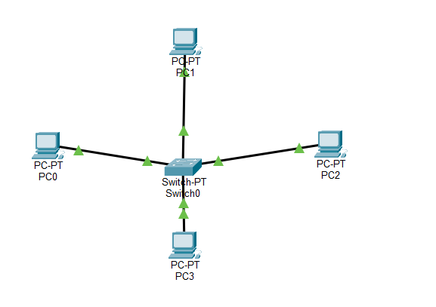
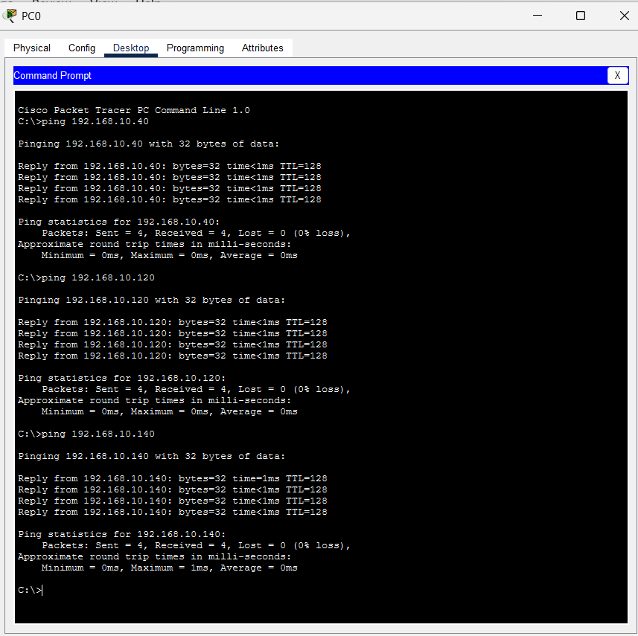
*-----------------------------------------------*

(2)
Subnet | Network | First Host | Last Host | Broadcast
1 | 192.168.30.0 | 192.168.30.1 | 192.168.30.126 | 192.168.30.127
2 | 192.168.30.128 | 192.168.30.129 | 192.168.30.254 | 192.168.30.255

*-----------------------------------------------*

The End

